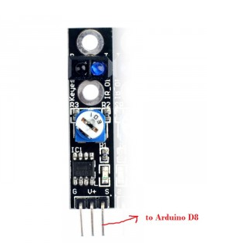

TCRT5000 infrared/optical tracking sensor can detect infrared light. If infrared light is detected, the module S pin will send high voltage signal to arduino or other device.  
****Step 1:**** Connect TCRT5000 module to Arduino as per following graph.

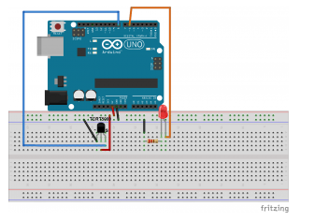

****Step 2:****Download [TCRT5000 sketch code](http://osoyoo.com/wp-content/uploads/samplecode/tcrt5000.txt), and load the code to Arduino IDE.  
When the sensor detects light or infrared, the LED will turn on. If you use your finger block the sensor, the LED will turn off.